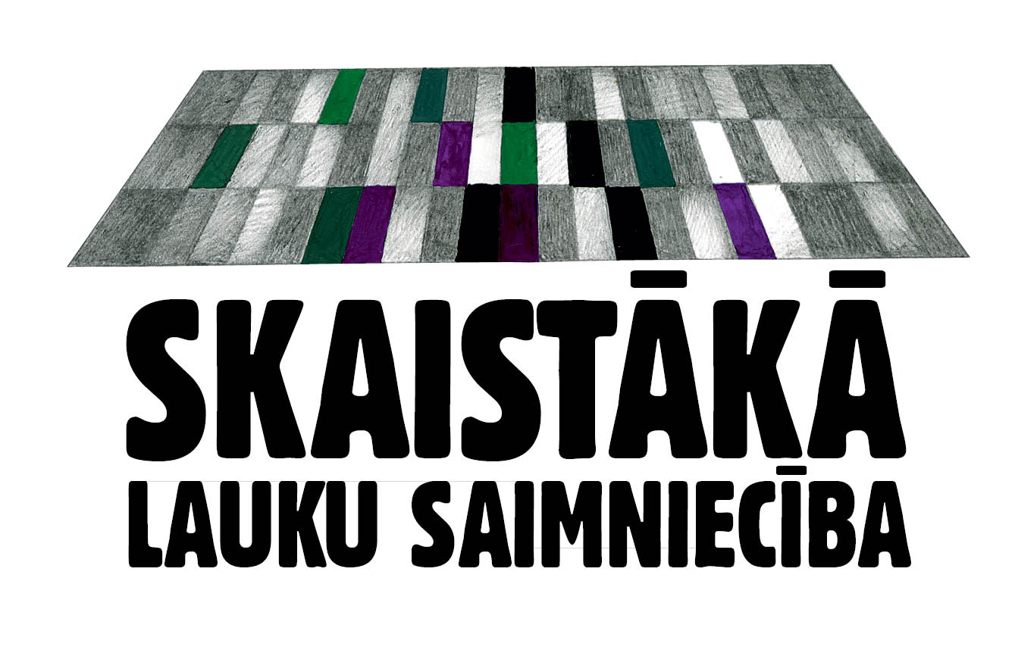



Information to the media
May 17, 2016

Fifth annual competition for the most beautiful homestead in Latvia commences

Any farm in Latvia that has a beautiful and neat homestead is welcome to participate in the competition for the Most Beautiful Homestead 2016, where the winner will be awarded a trip to International Green Week trade show in Berlin. Applications will be accepted until July 31 at saimnieciba@santa.lv, and the competition is open to all farms, regardless of their size, location, or specialization. The Most Beautiful Homestead 2016 is organized by Latvia’s leading dairy company Food Union and the only rural lifestyle magazine in Latvia, IEVAS Māja. President Raimonds Vējonis is the patron of the competition.

“We take great pride in every farm and homestead there is in Latvia. Seeing what the owners of the most beautiful farms in Latvia have achieved, I invite all residents of Latvia to draw inspiration from these examples and make their homesteads even more beautiful for the 100th anniversary of Latvia. This would make an excellent present to our Latvia and its people, and that is something that all of us can do. Let’s put our beautiful neat homes and homesteads on display, and be proud of where we live,” said President Raimonds Vējonis.

“The high opinion of the jury is a motivation to do even more. I certainly recommend other farmers to sign up – it’s definitely worth it,” the Markevics from the Vārpas farm, the winner of Most Beautiful Homestead 2016 competition, said urging other farmers to apply.

Just as last year, awards will be presented in two additional categories. Food Union will single out the Best New Farmstead 2016 to honor those well-tended farms that have been founded or inherited from the older generation over the past five years. Magazine Ievas Māja believes that every proper Latvian wants to live in his or her own Straumēni, a farmstead in full harmony with nature where several generations work shoulder to shoulder, honor ancient traditions, know the value of hard work and appreciate job well done. It is the spirit of Straumēni farm that the Ievas Māja magazine will be looking for at all farmsteads participating in the competition to eventually present the award Inheritors of the Spirit of Straumēni 2016.

“There are so many diligent and hardworking people in the Latvian countryside, who take great care of their farms and live in tidy and well-tended farmsteads. We have seen it in the finals of the competition the past several years. The winning farms represent traditional farming practices, such as dairy and grain farming, as well as outright non-traditional – snail farming and lavender farming. All of them make our homeland more beautiful, and we are genuinely proud to have such farms in our country. For this reason, this year we invite all who have not yet participated in the competition to write us so we could see how you run your farms,” said AS Rīgas piena kombināts (Food Union Group) Deputy Council Chairman and a member of the jury, Harijs Panke.

“I consider it to be a great gift to have the opportunity to visit the finalist farmsteads during the summer. First of all, this is because of the people I meet, their strong will and diligence. Second, it’ a chance to leave Riga every week and see the country where I live, and realize that we will indeed be strong and mighty as long as we have farmers like these. True, we Latvians are a modest folk who do not boast of their farmsteads, herds and cornfields. I call on one and all to stop being so humble and apply your farms for the competition – yours or the farm of your neighbors or relatives. Let’s be proud of what we do, and let’s be an inspiration to each other”, believes Kristīne Vilīte, Editor in Chief of the IEVAS Māja magazine.

The winner of the Most Beautiful Homestead 2016 competition will be awarded – courtesy Food Union – a paid trip to the Green Week in Berlin, the largest international food, agriculture and horticulture fair in the world that will take place on January 20-29, 2017, as well as other valuable presents from Food Union and magazine IEVAS Māja. All the finalists will be invited to attend the awards ceremony hosted by the President.

Any farm owner involved in farming, who lives in a beautiful and well-tended farmstead, is invited to participate in the competition. Just as last year, such farmsteads can be entered into competition by the friends, relatives, neighbors or cooperation partners of a given farm. The application has to include the name of the farm, name and surname of the farmer, the address, and contact details. The application also must include the name, surname, and contact information of the person entering the farm into the competition. Applications are to be sent to saimnieciba@santa.lv by July 31 this year. Full information about the rules of the competition can be found on www.manizurnali.lv

Additional information:
Aiva Ziemele,
Marketing Projects Manager
SIA Žurnāls SANTA
aiva.ziemele@santa.lv
Phone: 6 7006105

Linda Mežgaile,
Food Union Public Relations Manager
linda.mezgaile@mmacomms.lv
M + 371 2977 2050

